Student Name: Lau Ling Wang, Cheung Ho Chun
Student ID: 250230786, 250036418
Course: ITE3006: IT Essentials - Web
Assignment: EA2 - A Client-side Web Site of Your Own Interest
Topic: Hong Kong Flying Dragon Football Club (香港飛龍足球俱樂部)

1. Project Overview

This project involves the design and development of a multi-page, responsive client-side website for a fictional entity, the "Hong Kong Flying Dragon Football Club." The website is built using HTML5, CSS3, and vanilla JavaScript, adhering strictly to the assignment's constraints. The primary goal of the website is to promote the club, provide information to potential members, and attract new visitors to join the community.

The website consists of four interconnected pages, creating a coherent user journey from introduction to membership.

2. Website Structure and Pages

The website is structured around a central navigation menu, ensuring seamless movement between its four core pages. The file structure is organized by file type for better maintainability.

File Structure:
- index.html - The homepage (Start page).
- about.html - Information about the club.
- squad.html - Display of the club's current squad.
- join.html - A form for potential members to sign up.
- Css: style.css - All global and page-specific styles.
- Js: script.js - All client-side JavaScript logic.
- img/ - (Assumed folder for images, though placeholder images are used in code).
Page Details:

- Index.html (Homepage)
- Purpose: To serve as the main landing page, providing a quick overview of the club and its core activities. It aims to create an immediate, positive impression and encourage further exploration.
- Features:
- Responsive Navigation: A CSS-powered navigation bar that collapses into a "hamburger" menu on smaller screens.
- Hero Section: A visually prominent banner with the club's name, motto, and a clear call-to-action (CTA) button ("Join Us").
- Introductory Section: A brief overview of the club's history and mission, accompanied by a relevant image to increase visual appeal.
- Interactive Element: A JavaScript-powered countdown timer that dynamically displays the time remaining until the next home match, adding a sense of urgency and excitement.
- External Links: Footer containing links to the club's (placeholder) Facebook and Instagram pages.

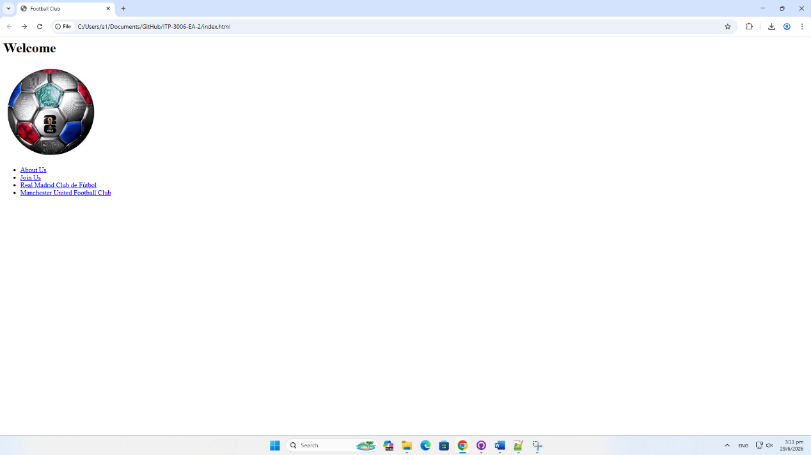

- about.html (About Us)
- Purpose: To provide in-depth information about the club's identity, values, and community. This page builds trust and connection with the visitor.
- Features:
- Responsive Layout: The "Who We Are," "What We Do," and "Our Values" sections are laid out in a clean, readable format that adapts to different screen sizes.
- Visuals: Each section is paired with an image to break up text and enhance engagement.
- Values Listing: The club's core values (Inclusivity, Excellence, Community) are highlighted with icons for easy scanning.
- Consistent Navigation: Shares the same responsive header and footer as the rest of the site.

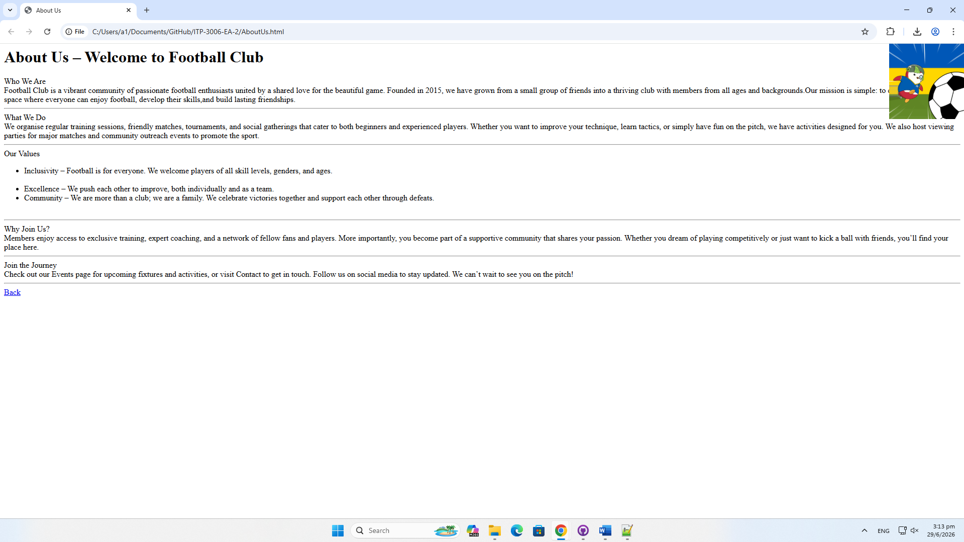

- squad.html (Player Squad)

- Purpose: To showcase the club's current players, adding a personal and professional touch to the website.
- Features:
- Player Cards: A grid of "cards" displays each player's name, position, jersey number, and a placeholder image.
- Responsive Grid: The card layout adjusts from a multi-column grid on desktop to a single column on mobile devices, ensuring usability across all platforms.
- Visual Appeal: The card design uses consistent styling, shadows, and colors to create a modern and professional look.

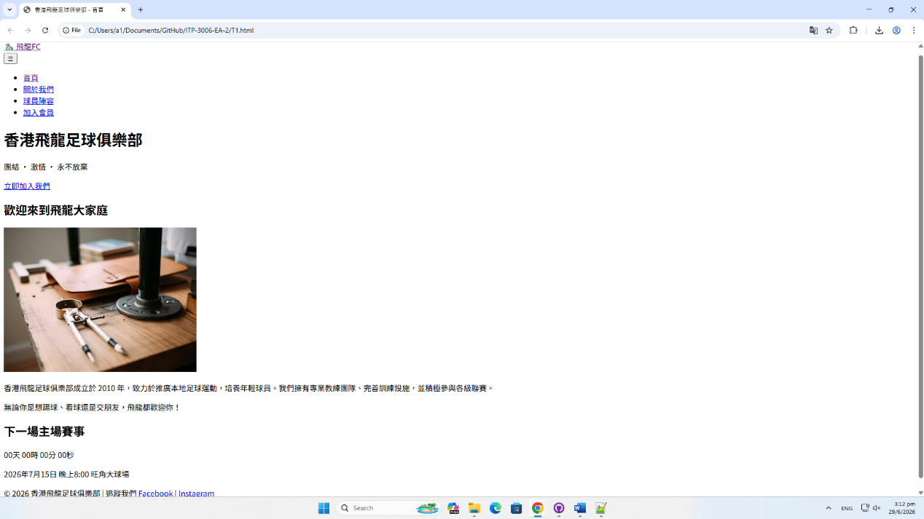

- join.html (Join Us)

- Purpose: To capture visitor information and convert them into club members. This page features the key interactive form.
- Features:
- HTML Form: A well-structured form collects essential member data.
- Input Elements: Includes text inputs (Name, Email, Phone), a dropdown menu (Position of Interest), a textarea (Message), and a radio button group (Skill Level).
- HTML5 Validation: The form uses built-in HTML5 attributes (required, type="email", type="tel", etc.) for immediate, browser-native validation.
- JavaScript Processing: Upon submission, a JavaScript function intercepts the form submission, performs custom validation (e.g., checking the message length), and displays a success or error message dynamically on the page without refreshing.
- Confirmation Modal: A friendly modal pop-up is triggered upon successful form validation, thanking the user for their submission.

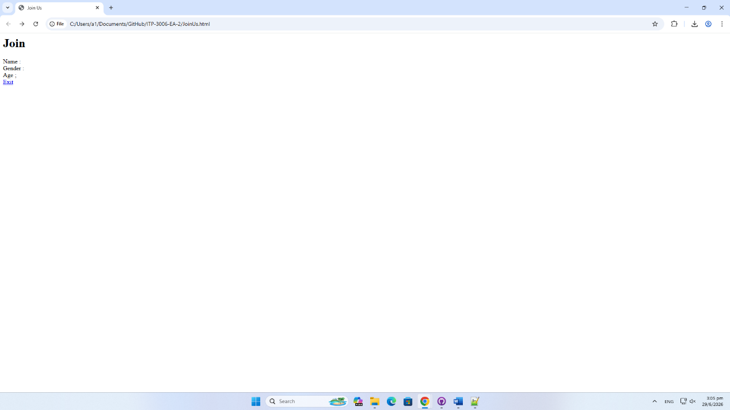

3. Compliance with Assignment Requirements
The submitted website has been developed to fully satisfy all requirements outlined in the assignment brief.
Requirement | Implementation | File/Code Location
Hyperlinks | Navigation menu, CTA buttons, Footer social media links | index.html (Nav & Footer), all pages
Text, Pictures, Video | Text content is rich and descriptive. Images are used as placeholders via picsum.photos. | All pages
Attractive Visual Effects | Hover effects on buttons and cards, responsive navigation, countdown timer. | style.css, script.js
CSS-powered menus | Navigation bar is styled entirely with CSS, including the dropdown/hamburger menu. | style.css
CSS-powered input/output | Form elements are fully styled with CSS. Output is shown via custom-styled message boxes. | style.css, join.html
Responsive Layout | All pages are responsive, adapting to screen sizes from mobile to desktop. | style.css (media queries)
Validation and Processing | HTML5 built-in validation and custom JavaScript validation are used on the sign-up form. | join.html, script.js

